**COMP 3340 Assignment 1 Part 2)**

**Question 1:**

Question 1A)

There is not strong correlation between variables within the students academic performance dataset, however the correlation between raisedHands and VisITedResources is the strongest with a 0.692 pearsons coefficient, which is almost defined as a strong correlation.

Table:

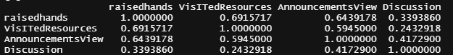

Code:



Question 1B)

(F) Students "raised hands" are more actively involved in study-related works

  
(F) No apparent gender bias when it comes to subject/topic choices



  
(T) Girls seem to have better overall performance than boys

(F) Boys are generally a bit more open to discussions, visiting resources, and raising hands

Means in Contribution by Gender.

(T) Those who participated more (higher counts in Discussion, Announcement Views,   
Raised Hands), usually perform better.

Means in contribution values by Results.



